Name: Archana Devi.P
Reg Number: 192521192
Course: Programming in Java
Code: CSA0923
Github Link: https://github.com/Archix17/CSA0923-JAVA
ASSIGNMENT 1

TASK 1 – Understand the Problem and Identify the Objects
1. Aim
To analyze the Campus Smart-Parking System and identify the objects, classes, responsibilities, inputs, outputs and business rules required to design a reliable object-oriented application using Java.
2. Problem Analysis
- The Campus Smart-Parking System manages parking spaces across multiple floors of a university.
- It supports two-wheelers, cars and electric vehicles. When a vehicle enters, the system allocates a suitable free slot and issues a parking ticket containing a unique ticket number and entry time.
- When the vehicle leaves, the system calculates the parking fee and releases the occupied slot.
- Students and staff with valid monthly passes can park free of charge, while visitors must pay the applicable fee.
- Electric vehicles may use charging slots and incur additional charging fees.
- The system should prevent duplicate parking allocations, invalid tickets and incorrect fee calculations.
- It should also support future extensions, such as new vehicle categories and pricing rules.

3. Inputs and Outputs
Inputs | Outputs
Vehicle registration number | Allocated floor and slot number
Vehicle type | Unique parking ticket
User category | Entry time and exit time
Monthly pass validity | Calculated parking fee
Parking duration | Slot availability status
Charging units consumed | Charging fee, where applicable

4. Candidate Classes and Their Responsibilities
Candidate class | Responsibilities | Why it is needed
Vehicle | Store registration number and common vehicle details | Represents every vehicle entering the facility
TwoWheeler | Define two-wheeler-specific properties and pricing | Supports vehicle-specific rules
Car | Define car-specific properties and pricing | Separates car behaviour from other vehicles
ElectricCar | Represent electric cars and charging capability | Supports charging-related operations
ParkingSlot | Store slot number, floor and occupancy status | Prevents two vehicles from occupying the same slot
ParkingFloor | Manage the slots on one floor | Organises parking spaces floor by floor
ParkingFacility | Allocate slots and release them when vehicles leave | Coordinates the entire parking facility
ParkingTicket | Store ticket number, vehicle, entry time and slot details | Records each parking session
ParkingUser | Store user category and pass details | Distinguishes students, staff and visitors
ParkingPass | Store pass validity and type | Determines eligibility for free or discounted parking
FeeCalculator | Calculate parking and charging fees | Separates pricing rules from parking operations

5. Nouns and Verbs Identified
Nouns that become candidate classes: vehicle, parking slot, floor, facility, ticket, user, pass and fee calculator.
Verbs that become methods:
- allocateSlot() – allocate a suitable free slot.
- releaseSlot() – release an occupied slot.
- issueTicket() – create a new parking ticket.
- calculateFee() – calculate the parking charge.
- validatePass() – check whether a parking pass is valid.
- calculateChargingFee() – calculate the EV charging charge.
- findVehicle() – locate a vehicle by registration number.
6. Business Rules
- A parking slot can hold at most one vehicle at a time.
- Every active parking session must have a unique ticket number.
- A vehicle cannot have two active parking tickets simultaneously.
- A vehicle must be allocated only to a suitable slot.
- An occupied slot must be released when the vehicle exits.
- Invalid floor numbers and slot numbers must be rejected.
- Parking fees must be calculated using the vehicle type and parking duration.
- A valid monthly pass must be checked before applying free parking.
- Electric vehicle charging fees must be calculated separately when applicable.
- The system must report when no suitable slot is available.
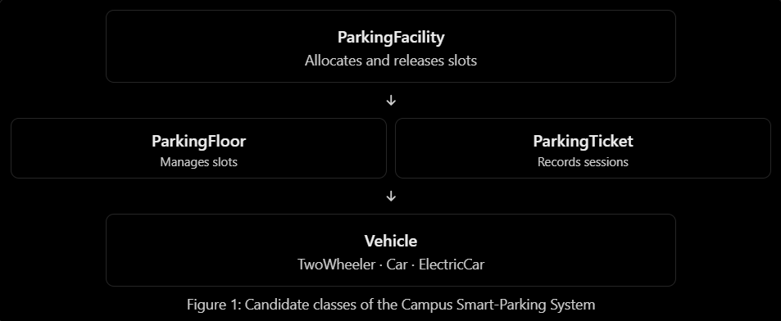
TASK 2 – Choose the Data Representation
1. Data Types Used
Data | Java data type | Reason
Floor number | int | Stores floor index
Slot number | int | Stores slot index
Vehicle registration number | String | Stores letters and digits
Entry and exit time | LocalDateTime | Stores date and time
Parking duration | long | Stores duration in minutes
Parking fee | double | Stores fees with decimal values
Slot occupancy | String | Stores registration number or null if free

2. Array Representation
A jagged two-dimensional array is suitable because each floor may contain a different number of parking slots.
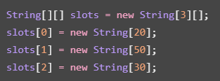
Each row represents a floor. Each element stores a vehicle registration number, while null indicates a free slot. This structure supports floors with different capacities.
3. Type Conversion and Precision
Integer division can produce an incorrect parking fee. For example:
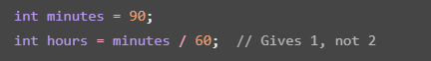
4. Program and output
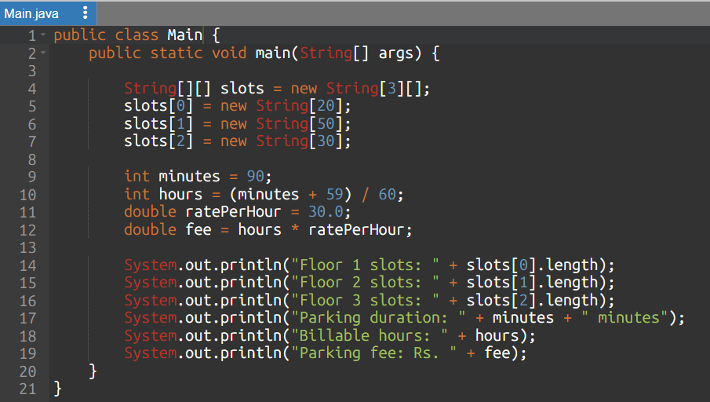
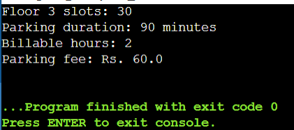
A one-dimensional array requires an index formula such as floor * slotsPerFloor + slot. This formula becomes unsuitable when floors have different capacities unless prefix offsets are maintained. Therefore, a jagged array is the better choice for this system.
Task 3 – Design the Control Logic
1. Aim
To implement a Java program that allocates free parking slots floor by floor and releases occupied slots after validating the floor and slot numbers.
2. Algorithm / Pseudocode
Allocation:
- Start from the first floor and first slot.
- Check each slot until a free slot is found.
- Store the vehicle number and return its floor and slot indices.
- If no free slot exists, return null.
Release:
- Check whether the floor and slot indices are valid.
- If the slot is occupied, set it to null and return true.
- Otherwise, return false.
3. Java Program
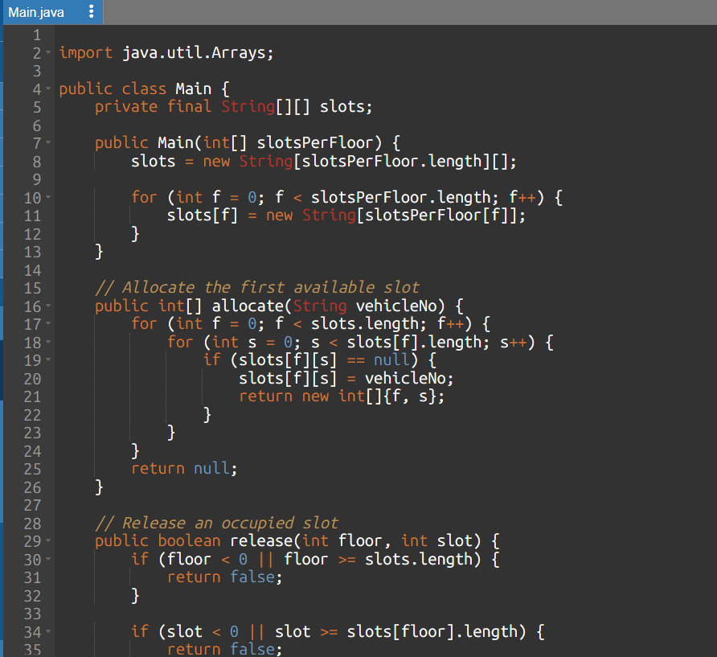
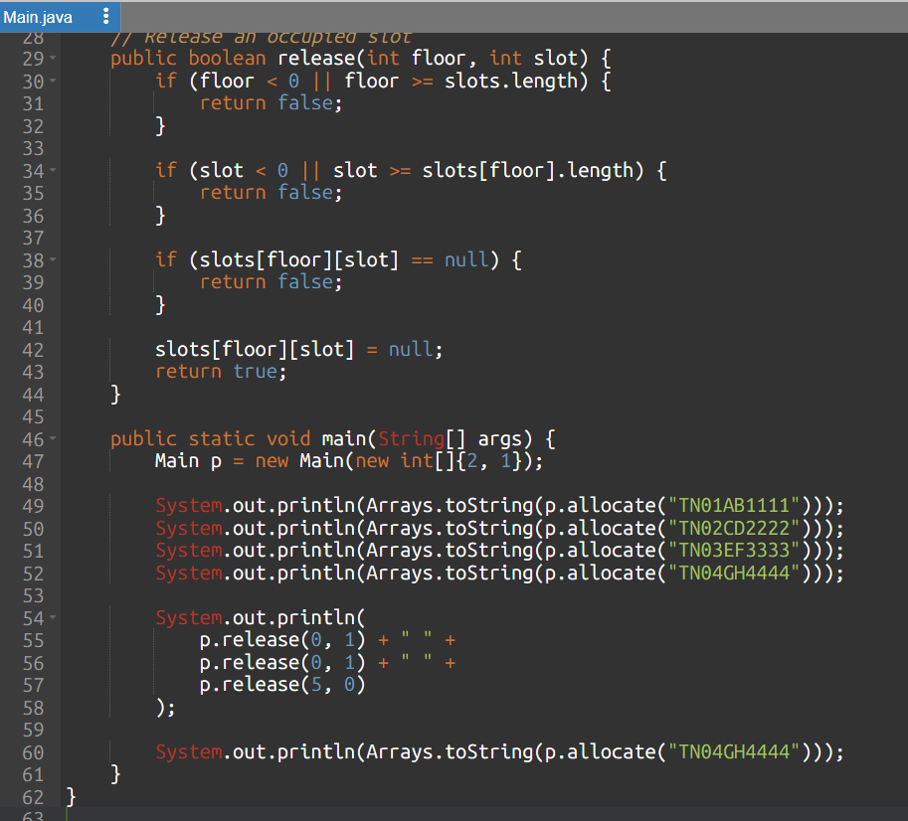
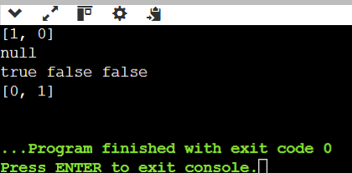
Time Complexity
- Allocation: O(N) in the worst case, where N is the total number of parking slots.
- Release: O(1), because it checks a specific slot directly.
- Space complexity: O(N) for storing the parking slots.

TASK 4 – Design Classes, Objects and Constructors
1. Aim
To demonstrate classes, objects, parameterized constructors, constructor overloading, constructor chaining using this, and validation of object data in Java.
2. Explanation
A class defines the properties and behaviour of an object. A constructor initializes an object when it is created.
- Default constructor: Initializes an object with default values.
- Parameterized constructor: Initializes an object with specified values.
- Constructor overloading: Allows multiple constructors with different parameter lists.
- this() keyword: Calls another constructor in the same class.
- Copy constructor: Creates an object using another object's data. A parking ticket should not reuse another ticket's unique ID.
3. Java Program
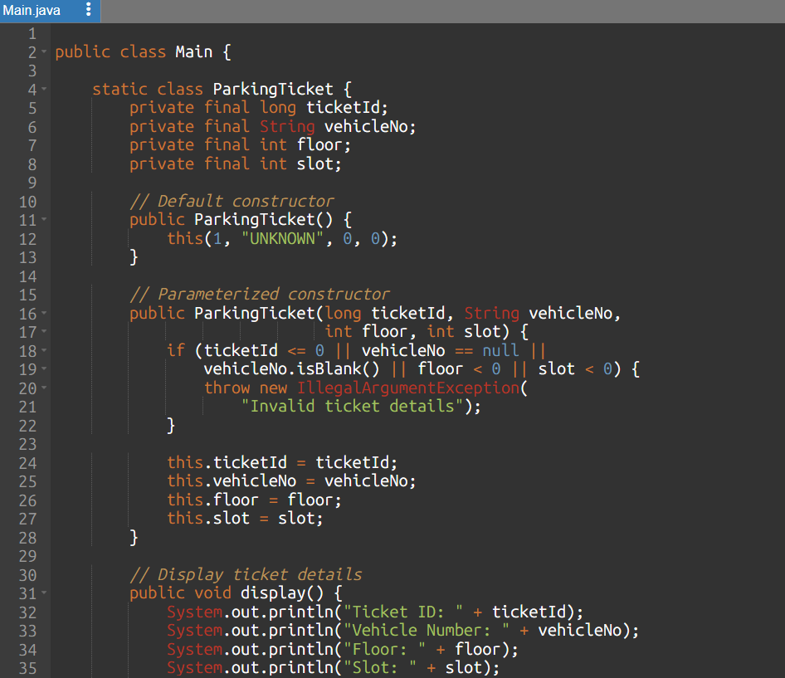
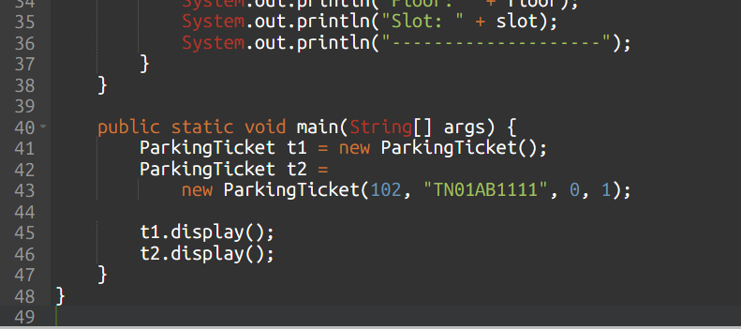
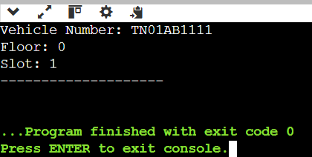
Complexity Analysis
- Creating one ticket takes O(1) time.
- Creating n tickets takes O(n) total time.
- Space complexity for n ticket objects is O(n).
TASK 5 – Apply Static Members and the Object Life Cycle
1. Aim
To demonstrate static variables, static methods, unique ticket numbering, and the life cycle of objects in Java.
2. Explanation
A static variable belongs to the class rather than to individual objects. Therefore, a shared ticket counter can generate unique ticket numbers for successive tickets.
- Static variable: Stores the common ticket counter.
- Static method: Can access static data without creating an object.
- Garbage collection: A ticket becomes eligible for garbage collection when it is no longer reachable, provided no other references retain it.
- Object references: Java passes object references by value.
3. Java Program
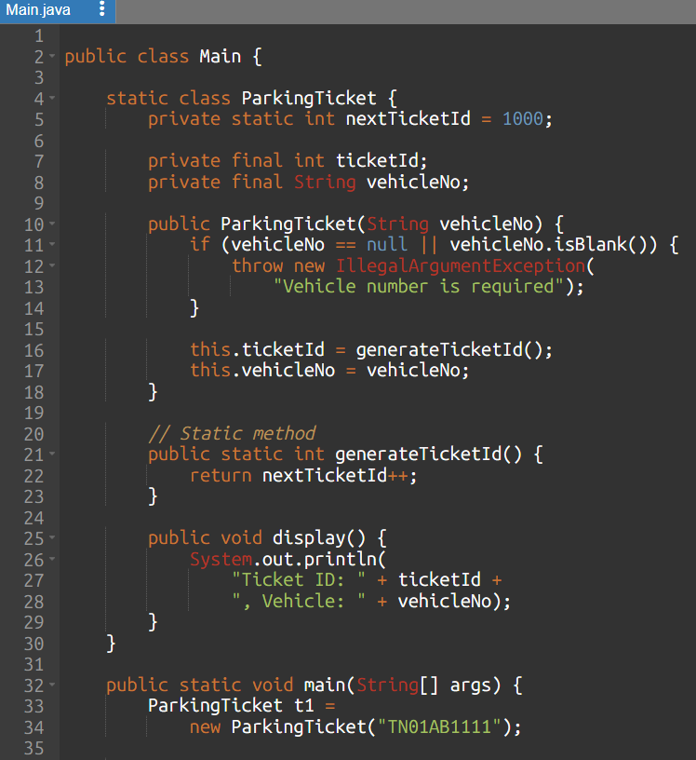
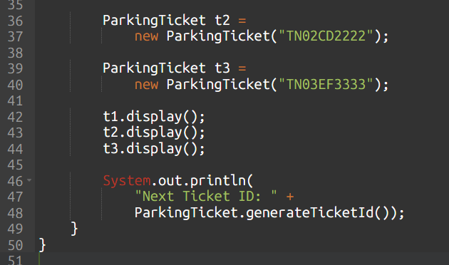
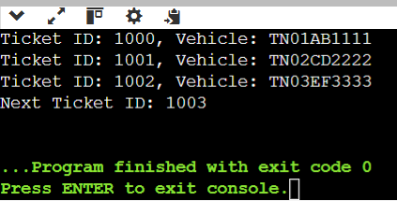
Complexity Analysis
- Generating one ticket ID takes O(1) time.
- Generating IDs for n tickets takes O(n) total time.
- The counter uses O(1) additional space, excluding the ticket objects.
- Storing n ticket objects requires O(n) space.
TASK 6 – Design the Inheritance Hierarchy
1. Aim
To implement inheritance in Java by creating a superclass Vehicle and subclasses TwoWheeler, Car, and ElectricCar.
2. Explanation
Inheritance allows a subclass to reuse the fields and methods of a superclass.
- Vehicle is the superclass containing the registration number.
- TwoWheeler and Car inherit from Vehicle.
- ElectricCar inherits from Car, demonstrating multilevel inheritance.
- The super() keyword calls the parent-class constructor.
3. Java Program
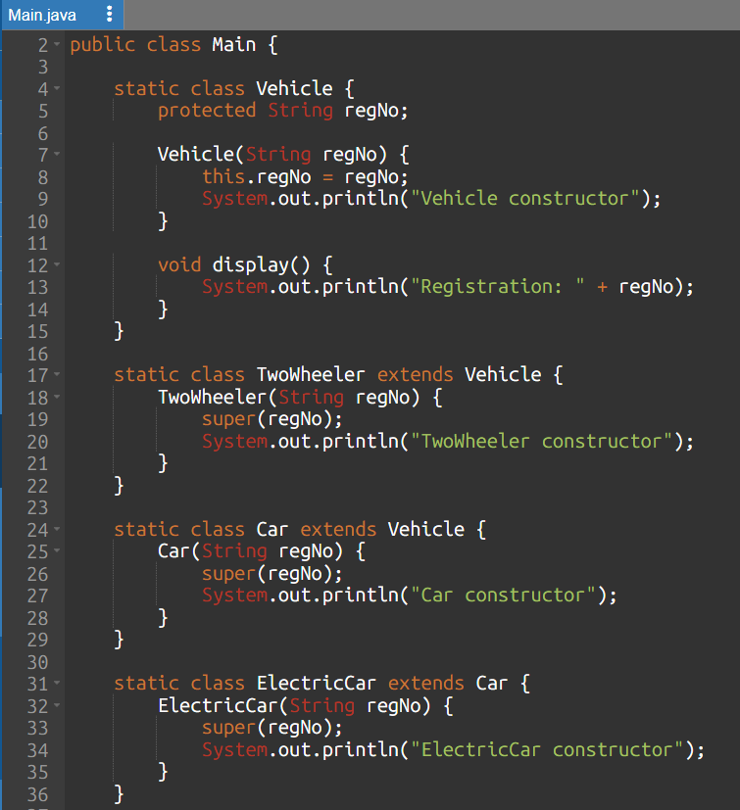
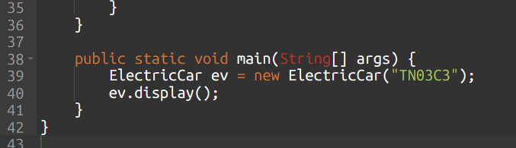

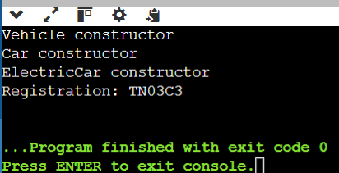
Complexity Analysis
- Object creation: O(1)
- Displaying vehicle details: O(1)
- Space for one vehicle object: O(1)

TASK 7 – Override and Specialise Behaviour

1. Aim
To demonstrate method overriding in Java by providing different parking rates for two-wheelers and cars, and to override toString(), equals() and hashCode().

2. Explanation
- Method overriding allows a subclass to provide its own implementation of a method inherited from its superclass.
- The @Override annotation helps the compiler verify that a method correctly overrides a parent method.
- The final keyword prevents a field from being reassigned.
- In this example, two vehicles with the same registration number are considered equal, even if they belong to different subclasses.
- This matches the equality rule in the assignment's supplied code, though a production parking system should validate registration numbers and prevent duplicate active registrations.

3. Java Program

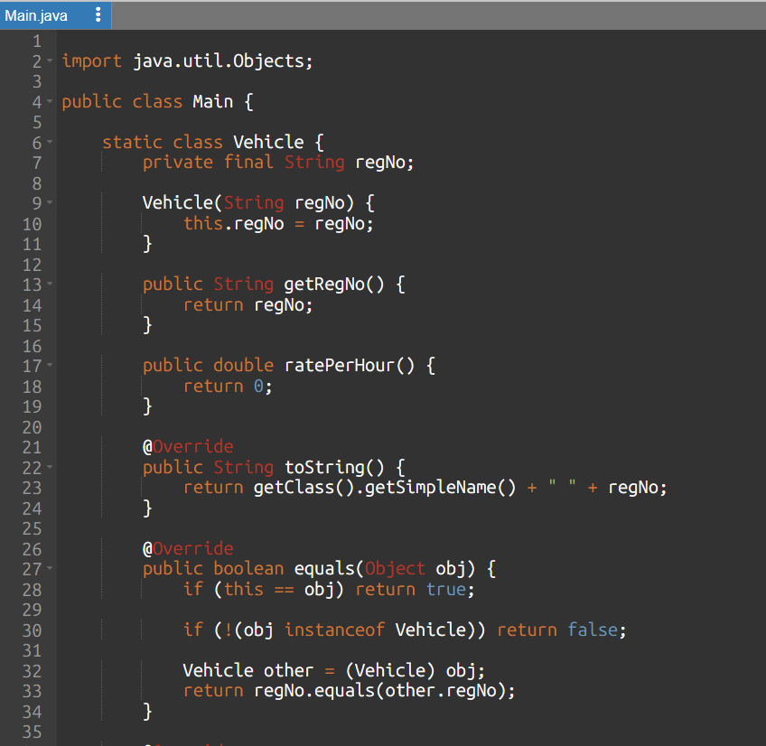
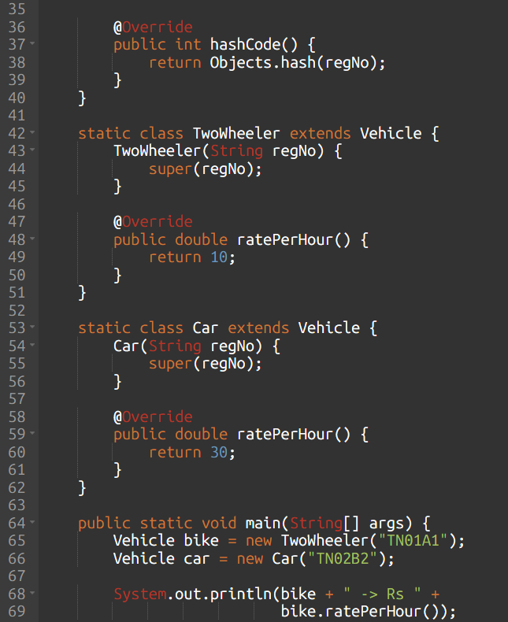
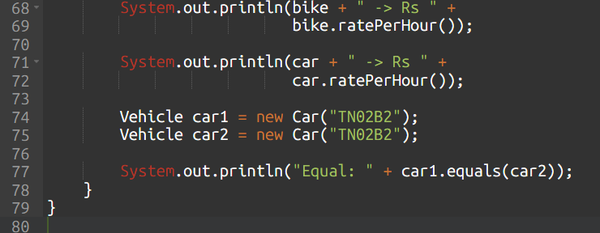

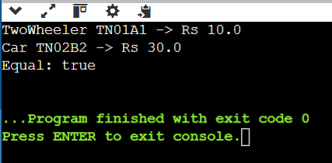
Complexity Analysis
- Rate calculation: O(1)
- Equality comparison: O(L) in the worst case, where L is the registration number length.
- Additional space per vehicle: O(1), excluding the registration string.
TASK 8 – Apply Polymorphism
1. Aim
To demonstrate compile-time and runtime polymorphism using method overloading, inheritance and dynamic method dispatch.
2. Explanation
- Compile-time polymorphism: Methods have the same name but different parameter lists. The compiler selects the correct overloaded method.
- Runtime polymorphism: A superclass reference can refer to a subclass object. Java selects the overridden method according to the actual object type.
For this program, calculateFee(int minutes) charges for started hours. The overloaded calculateFee(int hours, int minutes) demonstrates compile-time polymorphism.
3. Java Program
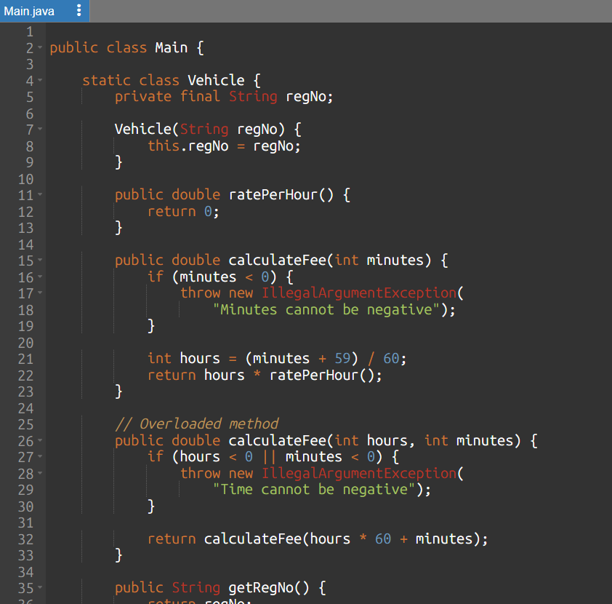
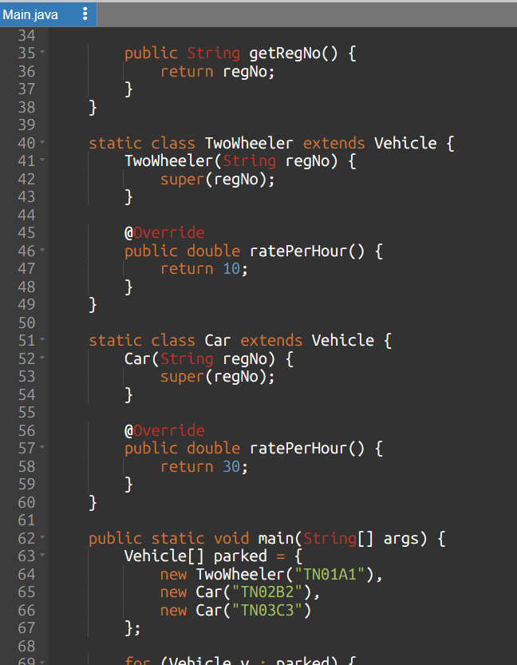
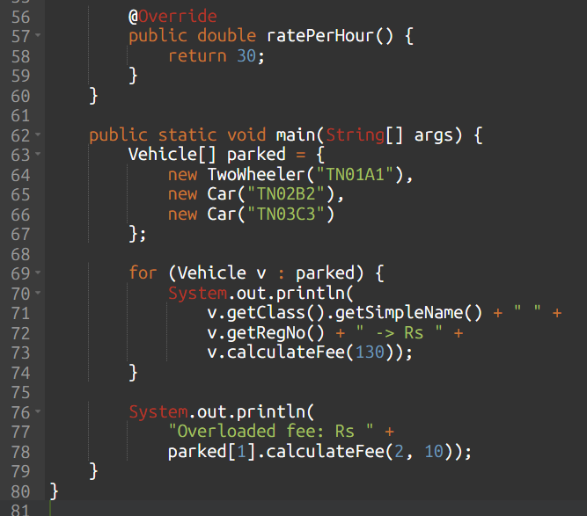
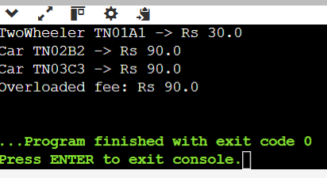
Complexity Analysis
- Fee calculation and dynamic dispatch: O(1)
- Processing n vehicles: O(n)
- Storage for n vehicle references: O(n), excluding the vehicle objects.

TASK 9 – Introduce Abstraction

1. Aim
To demonstrate abstraction using an abstract class and an interface in a campus smart-parking system.

2. Explanation
- An abstract class Vehicle defines common vehicle information and an abstract method for calculating the hourly rate.
- The Chargeable interface defines charging behavior for electric vehicles.
- This separates common properties from specialized capabilities.

3. Java Program
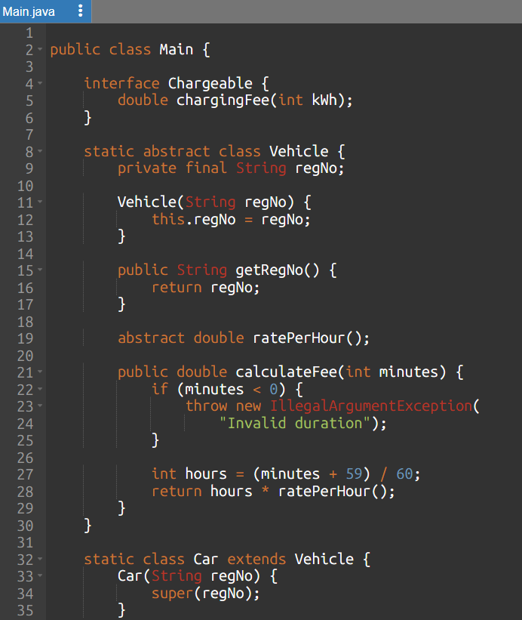
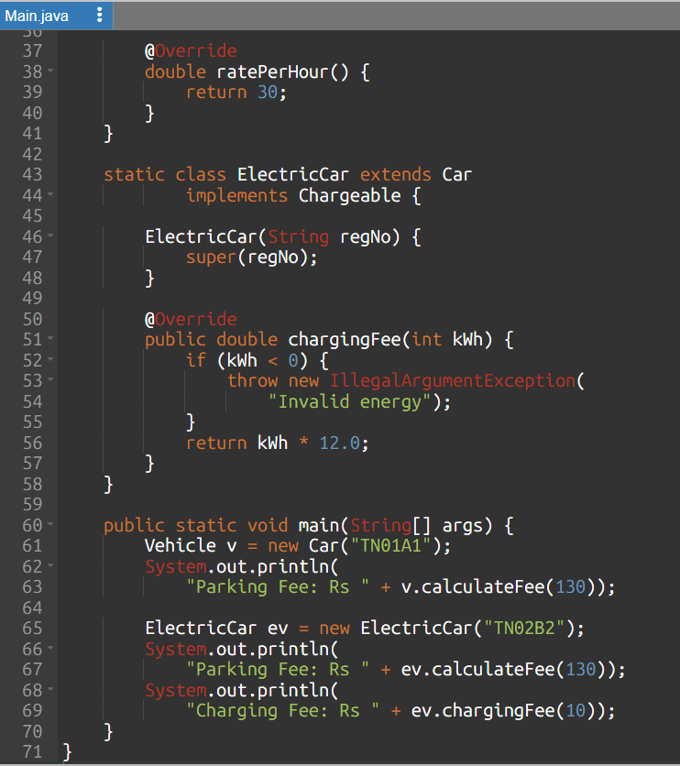
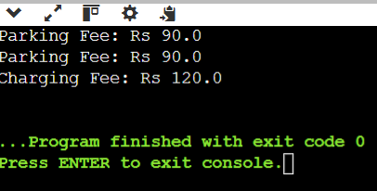
Complexity Analysis
- Parking-fee calculation: O(1)
- Charging-fee calculation: O(1)
- Space per vehicle object: O(1), excluding strings.

TASK 10 – Enforce Encapsulation through Packages and Access Modifiers

1. Aim
To demonstrate encapsulation using private fields, public methods and validation to protect vehicle data.

2. Explanation
- Encapsulation restricts direct access to object data.
- Private fields can be accessed or modified through public getters and validating setters.
- In a complete application, related classes can be organized into packages such as parking.model, parking.service and parking.app.

3. Java Program
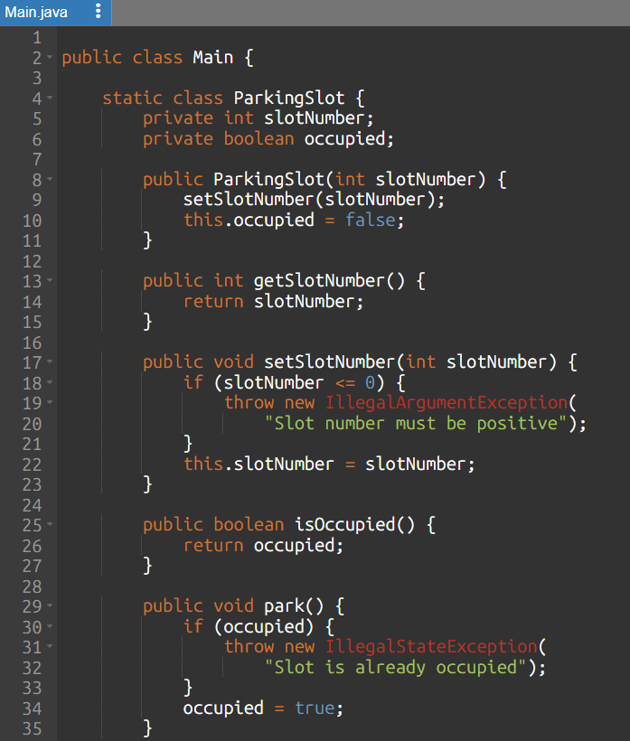
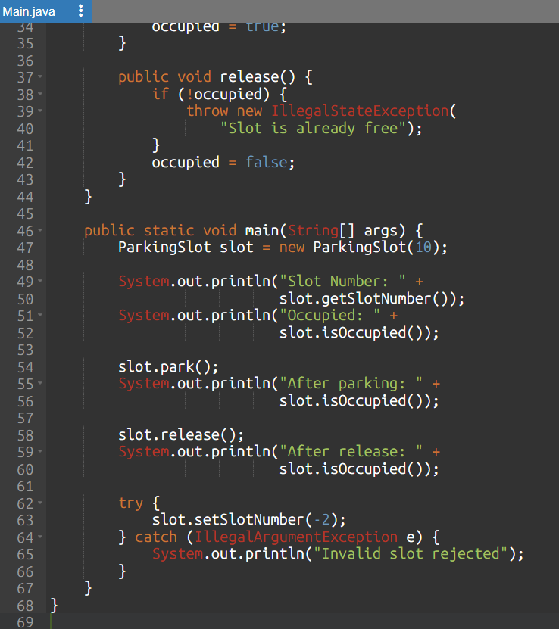
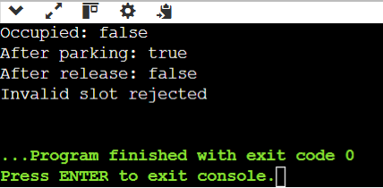
Complexity Analysis
- Reading or updating a field: O(1)
- Validation per update: O(1)
- Space per slot object: O(1)

TASK 11 – Implement, Test and Defend the Design

1. Aim
To implement a small parking system and validate vehicle entry, slot allocation, duplicate-registration prevention, exit processing and parking-fee calculation.

2. Explanation
- The system stores active vehicles in a HashMap, using registration numbers as keys.
- It rejects duplicate active registrations, allocates a free slot, calculates fees based on vehicle type and releases the slot when a vehicle exits.

3. Java Program

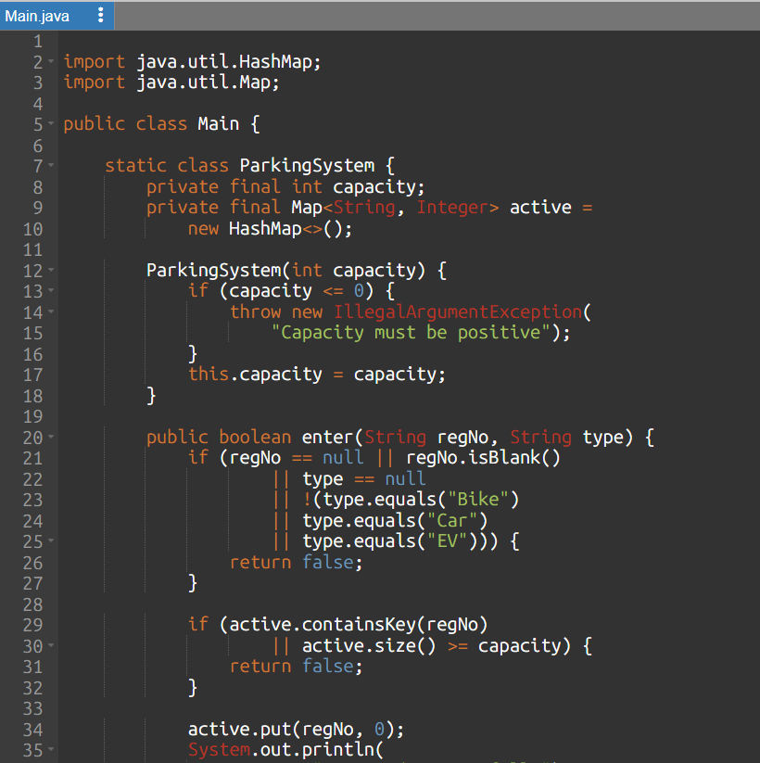
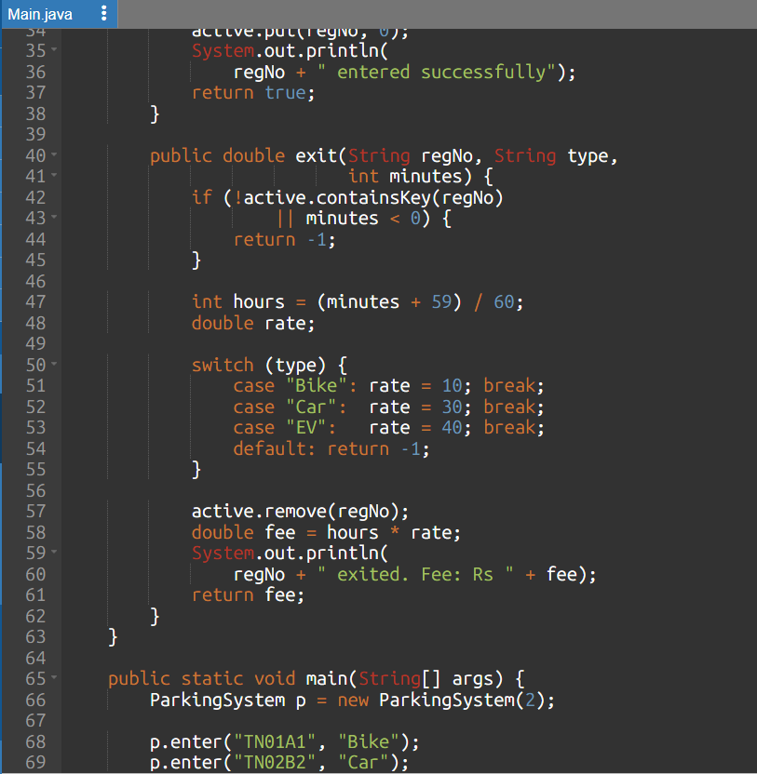
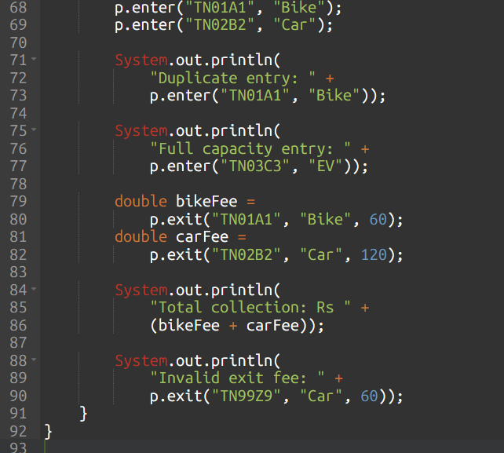
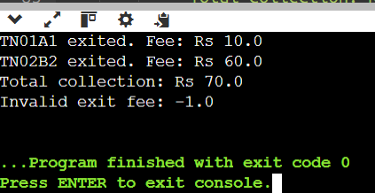
Complexity Analysis
- Entry and exit lookup: average O(1) using HashMap.
- Processing n vehicles: O(n) overall.
- Space for n active vehicles: O(n).

TASK 12 – Re-evaluate and Adapt the Design

A. Impact Analysis
- The university introduces e-bikes, delivery vans, a one-day visitor pass and a five-floor parking facility with unequal slot capacities.
- These changes affect vehicle classification, pricing rules, pass validation and parking-slot storage. A jagged array is suitable because each floor can have a different number of slots.

B. Evaluation of the Original Design
- A design with vehicle subclasses supports adding new vehicle categories through inheritance. However, placing all pricing rules inside vehicle subclasses becomes difficult when time-dependent rules and passes are introduced.
- Therefore, the design should be modified to separate pricing rules from vehicle information and to represent passes independently.

C. Adaptation and Implementation

Java Program
This compact implementation demonstrates e-bike pricing, delivery-van pricing during 9 AM–5 PM, one-day visitor passes and unequal floor capacities.
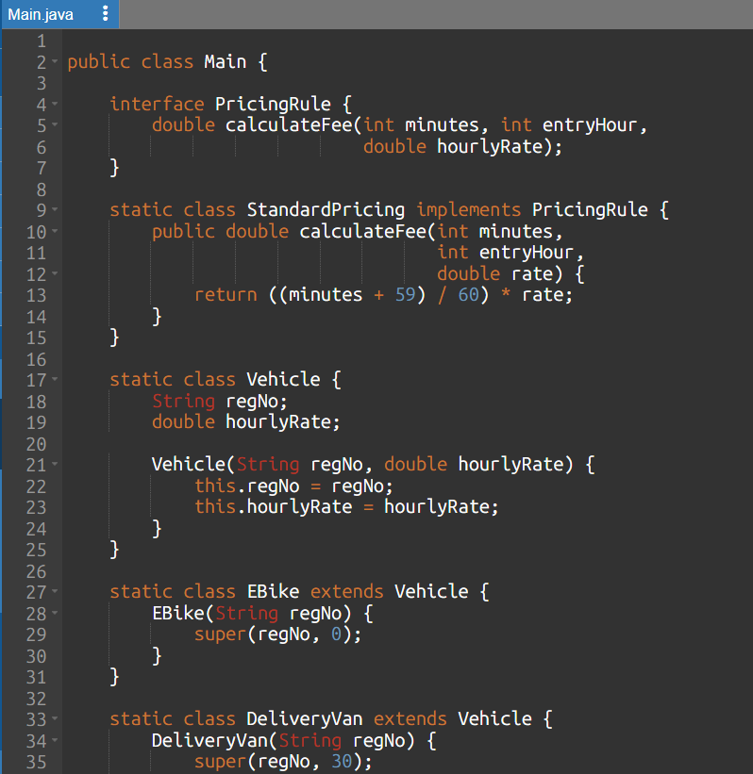
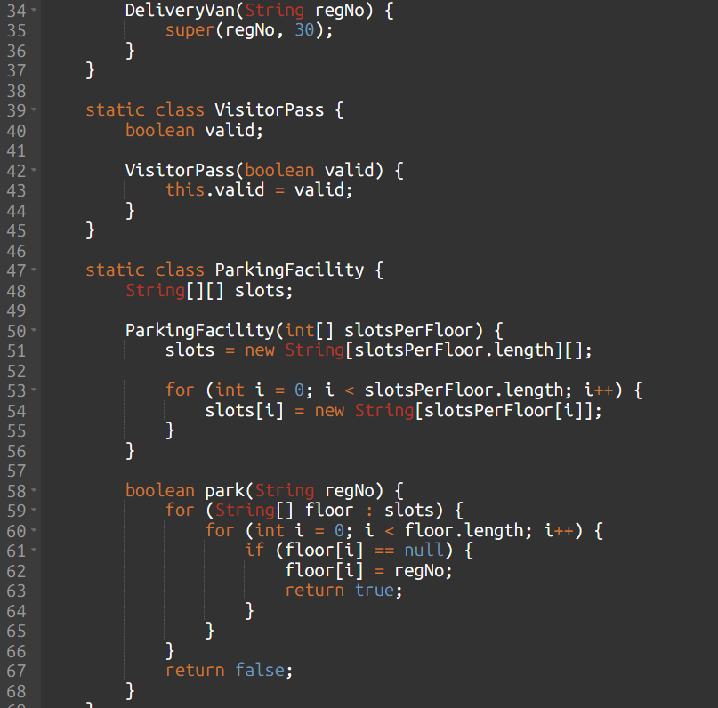
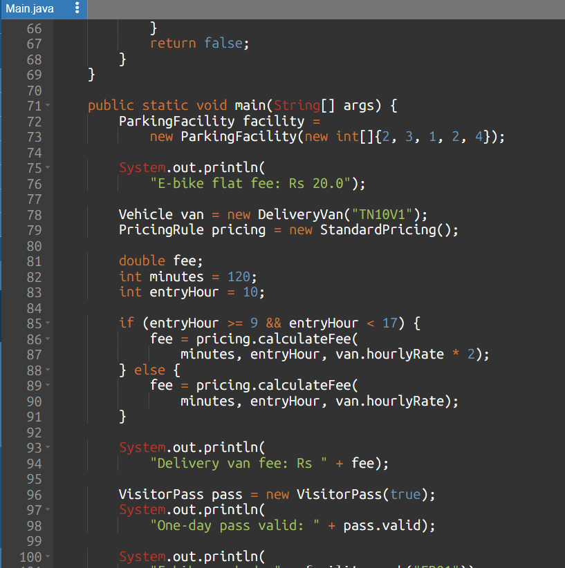
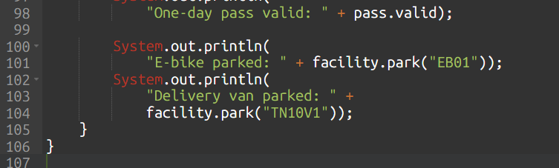
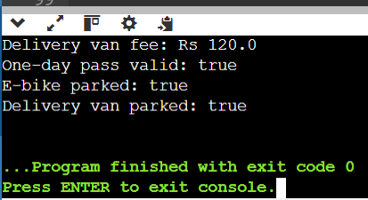
Complexity Analysis
- Parking-slot allocation: O(N) in the worst case, where \(N\) is the total number of slots.
- Fee calculation: O(1)
- Slot storage: O(N).

Final Result
- The Campus Smart-Parking System was designed and implemented using Java and object-oriented programming concepts.
- The tasks demonstrated classes and objects, constructors, static members, inheritance, method overriding, polymorphism, abstraction, interfaces, and encapsulation.
- The programs were executed and tested with sample inputs to verify vehicle registration, parking-slot allocation and release, ticket generation, fee calculation, and parking-capacity validation.
- The test results showed that the implemented methods performed as expected for the tested scenarios.
- Overall, this project demonstrates how object-oriented design can be used to build a simple, modular, and maintainable smart-parking system.
- It can be further improved by integrating a database, real-time slot monitoring, automated payments, and more advanced vehicle and pricing management.

